BANKING FINANCIAL
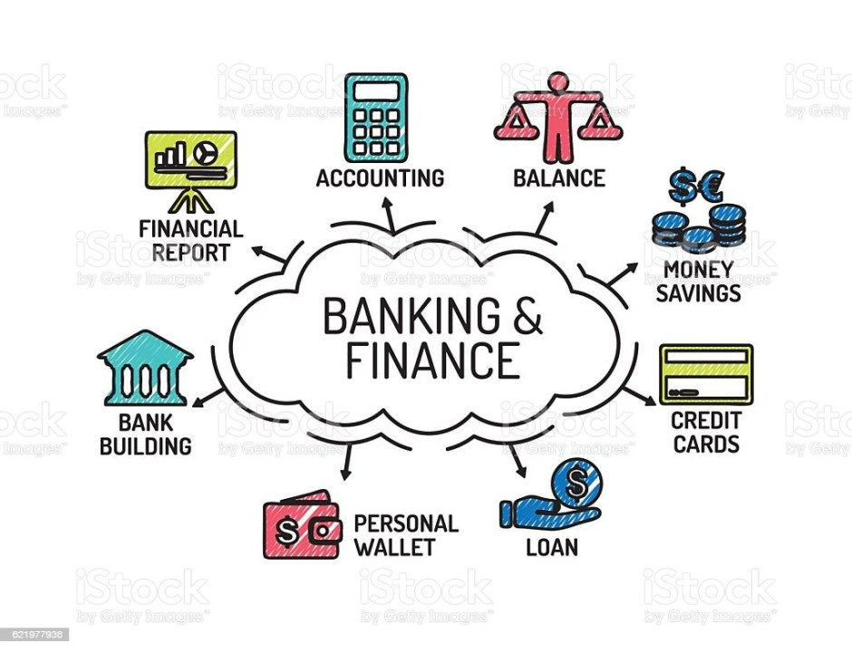

INTRODUCTION:
The banking dataset plays a vital role financial growth and customer trust.This project uses a banking complaints with the details of product type ,issues etc ..,The customers have multiple ways to complaint issues such as web ,Phone, email and posted mail etc ..,these complaints is crucial for improving customer satisfaction and service quality .Managing and analyzing the these factors.
OBJECTIVES:
- Identify the most common issues faced by customers.
- Measures company responses and resolution effectiveness.
- Highlights region with higher complaint volumes.
- Provides proper insights that can help banks improve financial services.
- Evaluate the different submission details.
- Identify the most common loan product.

TABE DESIGN:
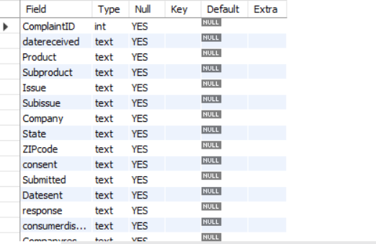

SQL QUERIES:
SELECT- It fetches the data in the table using the select query.
- Select*from banking;
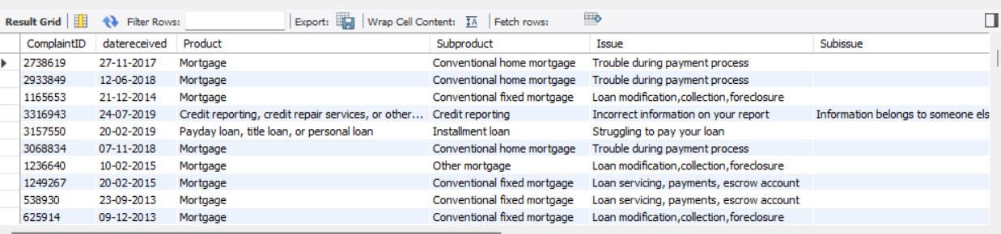
- It fetches all the columns from banking table.

WHERE- return the row where the data is.
- Select * from banking where product =’mortgage’;
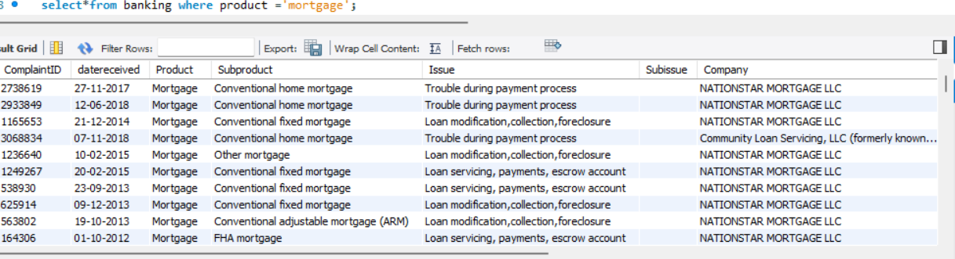
- Returns the rows where product is mortgage

DISTINCT-To get the unique value.
Select distinct product from banking;
- It retrieves the unique product
COUNT- The count is get the count of each row
- Select count (product) from banking;
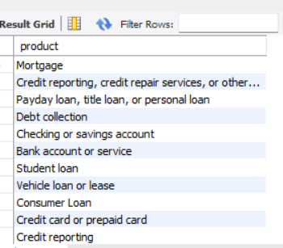
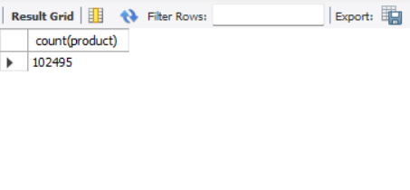
- It returns the count of the dataset.
COUNT &DISTINCT- I used for unique values count.
- Select count (distinct subproduct) as products from banking;
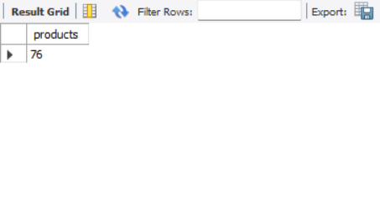
- It retrieves unique subproducts count.

ORDER BY- To get the values in the respective order.
- Select * from banking order by datereceived;
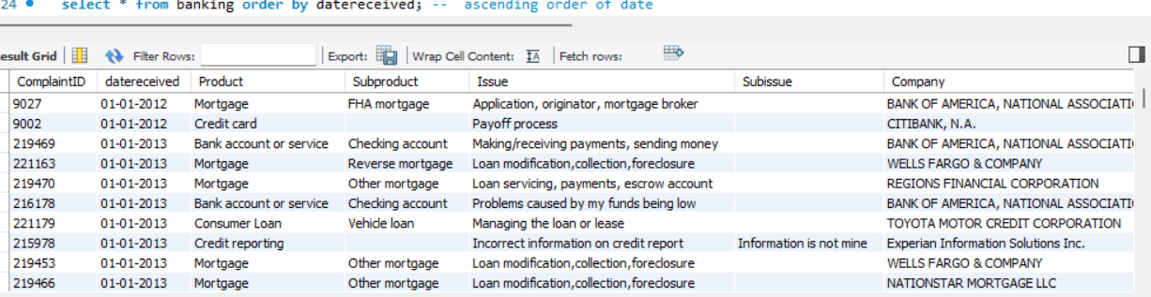
- It retrieves the datereceived columns in ascending order.
- Select * from banking order by datereceived desc;
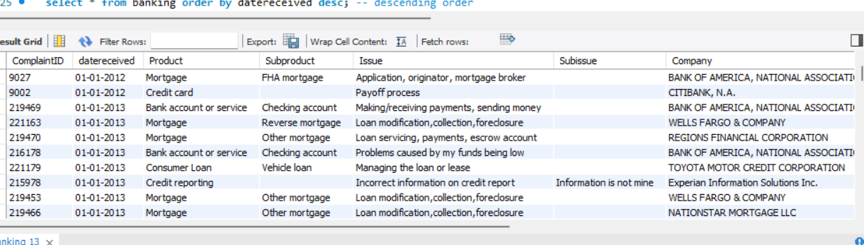
- It retrieves the datereceived columns in descending order.
- Select*from where subproduct='checking account' order by complaintID;
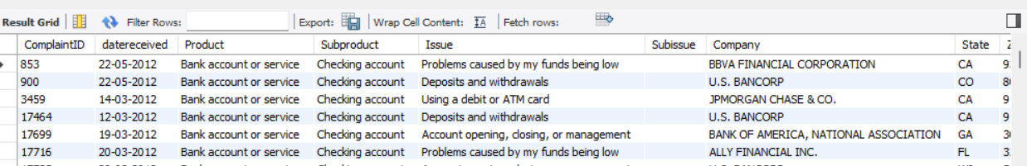
- It retrieves the subproduct is checking account based on the order of complainID.

GROUP BY- The group by is counts the subproducts in each products
- Select product ,count(subproduct) as pro from banking group by product;
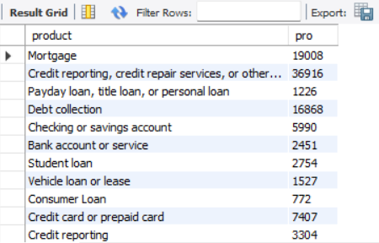
- It retrieves the counts subproducts in each product.
MULTIPLE COLUMNS IN GROUP BY:
- Select submitted, response,count(*) as counts from banking group by submitted,response;
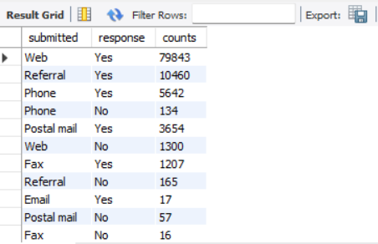
- It retrieves the count of the responses based on submitted.
Is Null: To get the columns that does not have the value.
- select product,Subissue from banking where Subissue is not null;
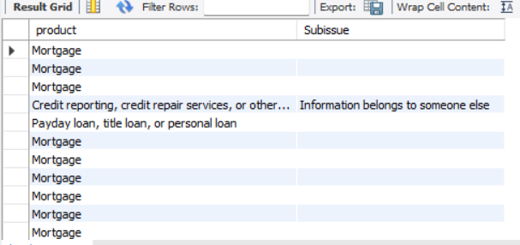

- It retrieves the null values in the subissue column.
Is Not Null: To get the columns that does have values.
- Select product,subproduct from banking where subproduct is not null;
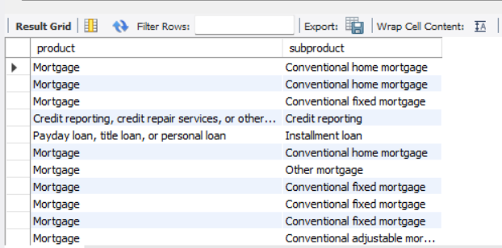
- It retrieves the values in subproduct values.
LOGICAL OPERATORS:
AND-it filters rows where both conditions are true.
- Select company,submitted from banking where company='NATIONSTAR MORTGAGE LLC' and submitted='Web' ;
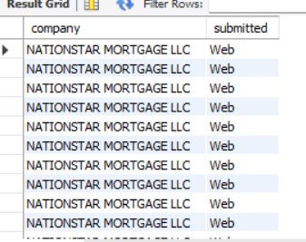
- It retrieves the company name and the complaint is submitted on web.
OR- it returns rows where the one condition is true.
- Select consumerdispute,companyresponse from banking where consumerdispute="yes" or companyresponse='closed with explanation';
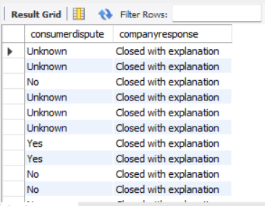
- It retrieves the consumerdispute=yes or companyresponse=closed with explanation.
View
A view is like a virtual table.
create view responses as select issue,subissue,company,companyresponse from banking where issue='Loan modification,collection,foreclosure';

- select * from responses;
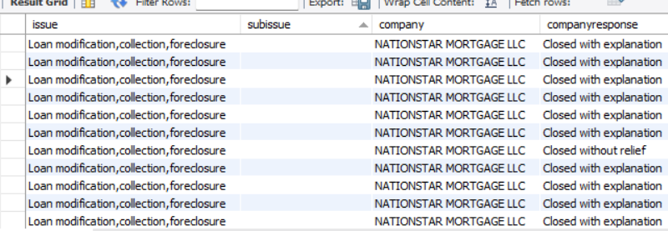

- Created responses table in banking which holds the issue,subissue , company and companyresponse.
STORED PROCEDURE:
- Created a procedure for receiveddate and sentdate as to understand the datedifference between the customer and the company. How fast we responded to the complaints.
- delimiter $$
create procedure receive_sent()
begin
select complaintID,datereceived,datesent,datediff(str_to_date (datesent,'%d-%m-%Y'),str_to_date(datereceived,'%d-%m-%Y')) as
com_received from banking;
select datereceived,datesent,
day(str_to_date(datereceived ,'%d-%m-%Y')) as rday,
month(str_to_date(datereceived ,'%d-%m-%Y')) as rmonth,
year(str_to_date(datereceived ,'%d-%m-%Y')) as ryear,
day(str_to_date(datesent ,'%d-%m-%Y')) as sday,
month(str_to_date(datesent ,'%d-%m-%Y')) as smonth,
year(str_to_date(datesent ,'%d-%m-%Y')) as syear from banking;

end $$
delimiter ;
call receive_sent();
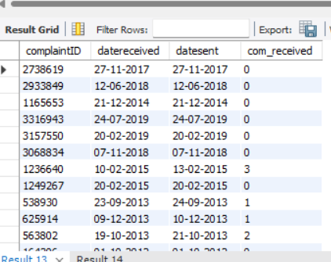
- Duration of the received and sentdate using the datedifference.
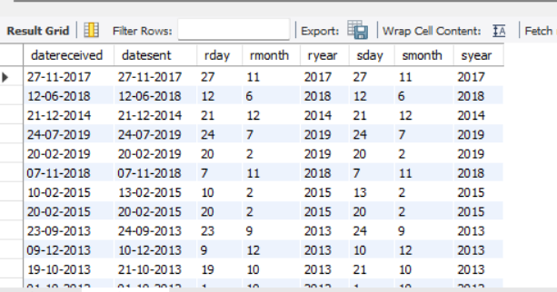

FUCTION:
delimiter $$
create function company_details(id int)
returns varchar(50)
deterministic
begin
declare details varchar(50);
select concat(company,state,ZIPcode) into details
from banking
where complaintID=id;
return details;
end $$
delimiter ;

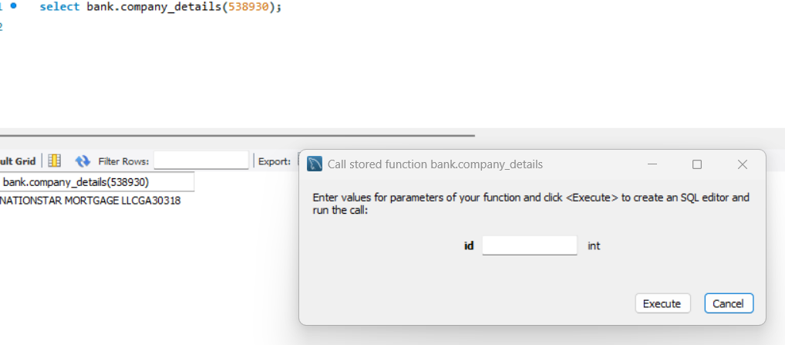


CONCLUSION:
The analysis shows that most complaints are concentrated in mortgage loan ,credit reporting/repair and debt collection.on otherside consumer loan and payday loans are attract the least complaints compared to other products.And most of complaints submitted in web,followed by phone.the preffered mode of complaints submission ,and improving folloe up on refferals can further enhance customer satisfaction.

